**PART A**

**EXPERIMENT NO. 6**

**A.1 Aim: -** To draw the State Diagram

**A.2 Prerequisite**

Determine the State Diagram for the case study.

**A.3 Outcome**

After successful completion of this experiment students will be able to -

1. Practice drawing the state diagrams using StarUML

**A.4 Procedure/Algorithm**

**A.4.1 Task:**

Draw a state diagram for the case study.

**PART B**

|  |  |
| --- | --- |
| Roll No: B017 | Name: Niharika Dalal |
| Class: B. Tech. Comp. Engg. | Batch: B1 |
| Date of Experiment: 14.3.2016 | Date of Submission: |
| Grade: |  |

**B.1 State Diagram**

………………………………………………………………………………………………………

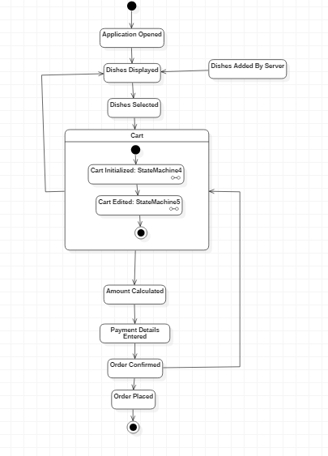

………………………………………………………………………………………………………

**B.4 Conclusion**

………………………………………………………………………………………………………

A state diagram is a type of [diagram](https://en.wikipedia.org/wiki/Diagram) used in [computer science](https://en.wikipedia.org/wiki/Computer_science) and related fields to describe the behavior of systems. State diagrams require that the system described is composed of a finite number of [states](https://en.wikipedia.org/wiki/State_(computer_science)).

In this practical, we have implemented State Diagram. Including States and Composite States comprising Submachine State. The Composite States have their own Start and Stop States to show flow of control within Submachine State.

………………………………………………………………………………………………………